**DBMS MINI PROJECT**

**TITLE: ONLE TRAIN TICKET BOOKING**

**RA191100301922**

**RAVULA GANESH KUMAR**

**DISCRIPTION:**

**Objective:-**

Through this system, a practical approach has been taken under study to understand how online reservation system works. This system will include all the necessary fields which are required during online reservation system. This system will be easy to use and can be used by any person. The basic idea behind this project is to save data in a central database which can be accessed by any authorize person to get information and saves time and burden which are being faced by their customers.

**Existing System:-**

Even though the online reservation system is available but the passengers have to fill all their necessary details using pen and paper which involves manual working. It’s the main counter is not open due to late arrival or due to some reasons then in this case, passengers have to wait and in certain cases they have to wait in line, waiting for their chance to come. After wasting so much time, customers able to get their answers and sometimes they did not positive response.

**Proposed System:-**

Through this system customers do not have to wait in line and they will able to get their answers in just a click. Through this system online form will be available by which passengers will able to fill their details along with their journey details. To book their seats, users will have to first search their trains as per their requirements and after getting correct train they will have to provide Train number. After pressing next button, it will show its status, whether it has been activated or in process. Online cancellation form will also be available and to cancel their reservation, they will have to provide their PNR number again to carry the next task.

SOURCE CODES

Welcome Screen

import java.awt.*;

import javax.swing.*;

class Welcome implements Runnable

{

JFrame f;

JLabel l1,l2,l3;

Thread t;

Login l;

ImageIcon img;

Welcome()

{

img=new ImageIcon("indian-rail.jpg");

t=new Thread(this);

f=new JFrame("Welcome");

f.getContentPane().setLayout(null);

f.getContentPane().setBackground(Color.yellow);

l1=new JLabel("OnLine Reservation");

l1.setBounds(250,300,900,50);

l1.setFont(new Font("Courier new",Font.BOLD,60));

l1.setForeground(Color.red);

l2=new JLabel(" _By Dushmanta Pradhan");

l2.setFont(new Font("Courier new",Font.BOLD,35));

l2.setBounds(350,380,800,40);

l2.setForeground(Color.red);

l3=new JLabel(img);

l3.setBounds(0,0,1300,1000);

f.getContentPane().add(l1);

f.getContentPane().add(l2);

f.getContentPane().add(l3);

f.setSize(1300,1000);

f.setVisible(true);

t.start();

}

public void run()

{

int x=1;

while(x<=5)

{

try

{

Thread.sleep(1000);

}

catch(Exception e)

{}

x++;

}

f.setVisible(false);

l=new Login();

}

}

Login Screen

import java.awt.*;

import java.awt.event.*;

import javax.swing.*;

class Login implements ActionListener

{

JFrame f;

JLabel l1,l2;

JTextField t1;

JPasswordField t2;

JButton b1,b2;

Main M;

Login()

{

f=new JFrame("Login");

f.getContentPane().setLayout(null);

f.getContentPane().setBackground(Color.pink);

l1=new JLabel("User Name");

l1.setForeground(Color.yellow);

l1.setBounds(50,50,100,30);

l2=new JLabel("Password");

l2.setForeground(Color.yellow);

l2.setBounds(50,80,100,30);

t1=new JTextField(10);

t1.setForeground(Color.blue);

t1.addActionListener(this);

t1.setBounds(150,50,100,30);

t2=new JPasswordField(10);

t2.setForeground(Color.blue);

t2.setEchoChar('*');

t2.addActionListener(this);

t2.setBounds(150,80,100,30);

b1=new JButton("Ok");

b1.setForeground(Color.blue);

b1.addActionListener(this);

b1.setBounds(50,120,100,30);

b2=new JButton("Cancel");

b2.setForeground(Color.blue);

b2.addActionListener(this);

b2.setBounds(180,120,100,30);

b1.setMnemonic('O');

b2.setMnemonic('C');

f.getContentPane().add(l1);

f.getContentPane().add(l2);

f.getContentPane().add(t1);

f.getContentPane().add(t2);

f.getContentPane().add(b1);

f.getContentPane().add(b2);

f.setBounds(300,300,300,200);

f.setResizable(false);

f.setVisible(true);

}

public void actionPerformed(ActionEvent e)

{

if(e.getSource()==b1)

{

if(t1.getText().length()==0||t2.getText().length()==0)

{

JOptionPane.showMessageDialog(null,"Fields are empty");

}

else if(t1.getText().equals("dush") && t2.getText().equals("1234"))

{

f.setVisible(false);

M=new Main();

}

else

{

JOptionPane.showMessageDialog(null,"Invalid User Name or Password");

}

}

if(e.getSource()==b2)

{

f.setVisible(false);

System.exit(0);

}

}

}

Main Screen

import java.awt.*;

import java.awt.event.*;

import javax.swing.*;

class Main implements ActionListener

{

JFrame f;

JButton b1,b2,b3,b4;

Reservation r;

Enquiry q;

Cancellation c;

JLabel imgL;

ImageIcon img;

Main()

{

img=new ImageIcon("Indian-Railway-Network.jpg");

imgL=new JLabel(img);

imgL.setBounds(0,0,1300,1000);

f=new JFrame("Main");

f.getContentPane().setLayout(null);

f.getContentPane().setBackground(Color.green);

b1=new JButton("Reservation Form");

b1.addActionListener(this);

b1.setBounds(150,390,210,60);

b2=new JButton("PNR-enquiry");

b2.addActionListener(this);

b2.setBounds(150,490,210,60);

b3=new JButton("Cancellation Form");

b3.addActionListener(this);

b3.setBounds(580,390,210,60);

b4=new JButton("Exit");

b4.addActionListener(this);

b4.setBounds(580,490,210,60);

b1.setBackground(new Color(100,200,0));

b1.setForeground(new Color(255,255,255));

b2.setBackground(new Color(100,200,0));

b2.setForeground(new Color(255,255,255));

b3.setBackground(new Color(100,200,0));

b3.setForeground(new Color(255,255,255));

b4.setBackground(new Color(100,200,0));

b4.setForeground(new Color(255,255,255));

b1.setMnemonic('R');

b2.setMnemonic('P');

b3.setMnemonic('C');

b4.setMnemonic('E');

f.getContentPane().add(b1);

f.getContentPane().add(b2);

f.getContentPane().add(b3);

f.getContentPane().add(b4);

f.getContentPane().add(imgL);

f.setSize(1300,1000);

f.setVisible(true);

}

public void actionPerformed(ActionEvent e)

{

if(e.getSource()==b1)

{

f.setVisible(false);

r=new Reservation();

}

if(e.getSource()==b2)

{

f.setVisible(false);

q=new Enquiry();

}

if(e.getSource()==b3)

{

f.setVisible(false);

c=new Cancellation();

}

if(e.getSource()==b4)

{

f.setVisible(false);

System.exit(0);

}

}

public static void main(String args[])

{

new Main();

}

}

Reservation Screen

import java.awt.*;

import java.awt.event.*;

import java.sql.*;

import javax.swing.*;

class Reservation extends Connect implements ActionListener,FocusListener

{

JFrame f;

JLabel l1,l2,l3,l4,l5,l6,l7,l8,l9,l10,l11,l12,l13;

JTextField t1,t2,t3,t4,t5,t6,t7;

Choice h;

JTextArea ta;

JButton b1,b2,b3;

PreparedStatement ps;

Statement st;

ResultSet rs;

int x;

JLabel imgL;

ImageIcon img;

void disable()

{

t1.setEnabled(false);

t2.setEnabled(false);

t3.setEnabled(false);

t4.setEnabled(false);

t5.setEnabled(false);

t6.setEnabled(false);

t7.setEnabled(false);

h.setEnabled(false);

b2.setEnabled(false);

}

void enable()

{

t1.setEnabled(true);

t2.setEnabled(true);

t3.setEnabled(true);

t4.setEnabled(true);

t5.setEnabled(true);

t6.setEnabled(true);

t7.setEnabled(true);

h.setEnabled(true);

b2.setEnabled(true);

}

Reservation()

{

img=new ImageIcon("LOGO1.jpg");

imgL=new JLabel(img);

imgL.setBounds(0,320,500,250);

f=new JFrame("Reservation");

f.getContentPane().setLayout(null);

f.getContentPane().setBackground(Color.green);

l1=new JLabel("PNR No");

l1.setBounds(130,50,100,30);

l2=new JLabel("Train No");

l2.setBounds(50,80,100,30);

l3=new JLabel("Train Name");

l3.setBounds(50,110,100,30);

l4=new JLabel("Class");

l4.setBounds(50,140,100,30);

l5=new JLabel("Date of Journey");

l5.setBounds(50,170,100,30);

l6=new JLabel("From");

l6.setBounds(50,200,100,30);

l7=new JLabel("To");

l7.setBounds(250,200,50,30);

l8=new JLabel("Boarding at");

l8.setBounds(50,230,100,30);

t1=new JTextField(10);

t1.setBounds(230,50,120,30);

t2=new JTextField(10);

t2.addFocusListener(this);

t2.setBounds(150,80,100,30);

t3=new JTextField(10);

t3.setBounds(150,110,100,30);

t4=new JTextField(10);

t4.setBounds(150,170,100,30);

t5=new JTextField(10);

t5.setBounds(150,200,100,30);

t6=new JTextField(10);

t6.setBounds(300,200,100,30);

t7=new JTextField(10);

t7.setBounds(150,230,100,30);

h=new Choice();

h.setBounds(150,140,100,30);

h.add("AC");

h.add("SL");

b1=new JButton("Insert");

b1.setBackground(Color.yellow);

b1.setBounds(50,270,100,30);

b1.addActionListener(this);

b2=new JButton("Next");

b2.setBackground(Color.yellow);

b2.setBounds(160,270,100,30);

b2.addActionListener(this);

b3=new JButton("Main");

b3.setBackground(Color.yellow);

b3.setBounds(270,270,100,30);

b3.addActionListener(this);

b1.setMnemonic('I');

b2.setMnemonic('N');

b3.setMnemonic('M');

f.getContentPane().add(l1);

f.getContentPane().add(l2);

f.getContentPane().add(l3);

f.getContentPane().add(l4);

f.getContentPane().add(l5);

f.getContentPane().add(l6);

f.getContentPane().add(l7);

f.getContentPane().add(l8);

f.getContentPane().add(t1);

f.getContentPane().add(t2);

f.getContentPane().add(t3);

f.getContentPane().add(t4);

f.getContentPane().add(t5);

f.getContentPane().add(t6);

f.getContentPane().add(t7);

f.getContentPane().add(h);

f.getContentPane().add(b1);

f.getContentPane().add(b2);

f.getContentPane().add(b3);

f.getContentPane().add(imgL);

f.setSize(1300,1000);

f.setVisible(true);

disable();

}

public void focusLost(FocusEvent e)

{

if(t2.getText().length()!=0)

{

try

{

ps=con.prepareStatement("select Train_Name from Train where Train_No=?");

ps.setString(1,t2.getText());

rs=ps.executeQuery();

if(rs.next())

{

t3.setText(rs.getString(1));

}

}

catch(Exception e1)

{

System.out.println("Connection failed:"+e1);

}

}

}

public void focusGained(FocusEvent e)

{}

public void actionPerformed(ActionEvent e)

{

if(e.getSource()==b1)

{

enable();

b1.setEnabled(false);

try

{

st=con.createStatement();

rs=st.executeQuery("select * from PNR");

rs.next();

x=rs.getInt(1);

t1.setText(String.valueOf(x));

}

catch(Exception e1)

{

System.out.println("Connection failed:"+e1);

}

}

if(e.getSource()==b2)

{

try

{

ps=con.prepareStatement("insert into Reservation values(?,?,?,?,?,?,?,?)");

ps.setString(1,t1.getText());

ps.setString(2,t2.getText());

ps.setString(3,t3.getText());

ps.setString(4,h.getSelectedItem());

ps.setString(5,t4.getText());

ps.setString(6,t5.getText());

ps.setString(7,t6.getText());

ps.setString(8,t7.getText());

ps.executeUpdate();

//update PNR no.

ps=con.prepareStatement("update PNR set PNR_No=? where PNR_No=?");

ps.setInt(1,(x+1));

ps.setInt(2,x);

ps.executeUpdate();

JOptionPane.showMessageDialog(null, "Record Saved");

b1.setEnabled(true);

b2.setEnabled(false);

f.setVisible(false);

}

catch(Exception e1)

{

System.out.println("Connection failed:"+e1);

}

try

{

st=con.createStatement(ResultSet.TYPE_SCROLL_INSENSITIVE,ResultSet.CONCUR_READ_ONLY);

rs=st.executeQuery("select * from Reservation");

rs.last();

x=rs.getInt(1);

Passenger P=new Passenger(x);

st=con.createStatement();

rs=st.executeQuery("select * from PassengerID");

rs.next();

x=rs.getInt(1);

P.t1.setText(String.valueOf(x));

ps=con.prepareStatement("update PassengerID set PID=? where PID=?");

ps.setInt(1,(x+1));

ps.setInt(2,x);

ps.executeUpdate();

}

catch(Exception e1)

{

System.out.println("Connection failed:"+e1);

}

}

if(e.getSource()==b3)

{

f.setVisible(false);

new Main();

}

}

public static void main(String args[])

{

new Reservation();

}

}

Passenger.java

import java.awt.*;

import java.awt.event.*;

import java.sql.*;

import javax.swing.*;

class Passenger extends Connect implements ActionListener

{

JFrame f;

JLabel l1,l2,l3,l4,l5,l6;

JTextField t1,t2,t3;

JButton b1,b2,b3;

Checkbox c1,c2,c3,c4,c5;

CheckboxGroup cbg;

JTextArea ta;

PreparedStatement ps;

Statement st;

ResultSet rs;

int pno;

JLabel imgL;

ImageIcon img;

Passenger(int p)

{

pno=p;

img=new ImageIcon("LOGO2.jpg");

imgL=new JLabel(img);

imgL.setBounds(0,400,400,200);

f=new JFrame("Passenger");

f.getContentPane().setLayout(null);

f.getContentPane().setBackground(Color.green);

l1=new JLabel("PId");

l1.setBounds(50,50,100,30);

t1=new JTextField(10);

t1.setBounds(170,50,100,30);

l2=new JLabel("Name of Passenger");

l2.setBounds(50,80,120,30);

t2=new JTextField(10);

t2.setBounds(170,80,100,30);

l3=new JLabel("Age");

l3.setBounds(50,130,100,30);

t3=new JTextField(10);

t3.setBounds(150,130,50,30);

l4=new JLabel("Gender");

l4.setBounds(250,130,50,30);

ta=new JTextArea(5,10);

ta.setBounds(150,170,130,70);

l5=new JLabel("Address");

l5.setBounds(50,170,100,30);

l6=new JLabel("Catagory");

l6.setBounds(50,240,100,30);

b1=new JButton("More");

b1.setBackground(Color.yellow);

b1.addActionListener(this);

b1.setBounds(50,330,100,30);

b2=new JButton("Save");

b2.setBackground(Color.yellow);

b2.addActionListener(this);

b2.setBounds(170,330,100,30);

b3=new JButton("Back");

b3.setBackground(Color.yellow);

b3.addActionListener(this);

b3.setBounds(290,330,100,30);

b1.setMnemonic('M');

b2.setMnemonic('S');

b3.setMnemonic('B');

cbg=new CheckboxGroup();

c1=new Checkbox("Male",cbg,true);

c1.setBounds(300,130,100,30);

c2=new Checkbox("Female",cbg,false);

c2.setBounds(300,160,100,30);

c3=new Checkbox("General");

c3.setBounds(150,240,100,30);

c4=new Checkbox("Senior Citizen");

c4.setBounds(150,270,100,30);

c5=new Checkbox("Ex-serviceman");

c5.setBounds(150,300,100,30);

f.getContentPane().add(l1);

f.getContentPane().add(l2);

f.getContentPane().add(l3);

f.getContentPane().add(l4);

f.getContentPane().add(l5);

f.getContentPane().add(l6);

f.getContentPane().add(t1);

f.getContentPane().add(t2);

f.getContentPane().add(t3);

f.getContentPane().add(ta);

f.getContentPane().add(b1);

f.getContentPane().add(b2);

f.getContentPane().add(b3);

f.getContentPane().add(c1);

f.getContentPane().add(c2);

f.getContentPane().add(c3);

f.getContentPane().add(c4);

f.getContentPane().add(c5);

f.getContentPane().add(imgL);

f.setSize(1300,1000);

f.setVisible(true);

}

public void actionPerformed(ActionEvent e)

{

if(e.getSource()==b1)

{

try

{

//saving existing record

String cat="";

ps=con.prepareStatement("insert into TempPassenger values(?,?,?,?,?,?,?)");

ps.setString(1,t1.getText());

ps.setString(2,t2.getText());

ps.setString(3,t3.getText());

ps.setString(4,cbg.getSelectedCheckbox().getLabel());

ps.setString(5,ta.getText());

if(c3.getState())

cat+=c3.getLabel()+",";

if(c4.getState())

cat+=c4.getLabel()+",";

if(c5.getState())

cat+=c5.getLabel()+",";

ps.setString(6,cat);

ps.setInt(7,pno);

ps.executeUpdate();

ps.close();

//opening new form

Passenger P=new Passenger(pno);

st=con.createStatement();

rs=st.executeQuery("select * from PassengerID");

rs.next();

int x=rs.getInt(1);

P.t1.setText(String.valueOf(x));

st.close();

//update passenger id

ps=con.prepareStatement("update PassengerID set PID=? where PID=?");

ps.setInt(1,(x+1));

ps.setInt(2,x);

ps.executeUpdate();

ps.close();

}

catch(Exception e1)

{

System.out.println("Connection failed:"+e1);

}

}

if(e.getSource()==b2)

{

try

{

String cat="";

ps=con.prepareStatement("insert into TempPassenger values(?,?,?,?,?,?,?)");

ps.setString(1,t1.getText());

ps.setString(2,t2.getText());

ps.setString(3,t3.getText());

ps.setString(4,cbg.getSelectedCheckbox().getLabel());

ps.setString(5,ta.getText());

if(c3.getState())

cat+=c3.getLabel()+",";

if(c4.getState())

cat+=c4.getLabel()+",";

if(c5.getState())

cat+=c5.getLabel()+",";

ps.setString(6,cat);

ps.setInt(7,pno);

ps.executeUpdate();

ps.close();

st=con.createStatement();

rs=st.executeQuery("select * from TempPassenger");

while(rs.next())

{

ps=con.prepareStatement("insert into Passenger values(?,?,?,?,?,?,?)");

ps.setString(1,rs.getString(1));

ps.setString(2,rs.getString(2));

ps.setString(3,rs.getString(3));

ps.setString(4,rs.getString(4));

ps.setString(5,rs.getString(5));

ps.setString(6,rs.getString(6));

ps.setString(7,rs.getString(7));

ps.executeUpdate();

ps.close();

}

st=con.createStatement();

st.executeUpdate("delete from TempPassenger");

JOptionPane.showMessageDialog(null,"Record Saved");

b2.setEnabled(false);

b1.setEnabled(false);

st.close();

}

catch(Exception e1)

{

System.out.println("Connection failed:"+e1);

}

}

if(e.getSource()==b3)

{

f.setVisible(false);

new Reservation();

}

}

public static void main(String args[])

{

new Passenger(0);

}

}

Enquiry. Java

import java.awt.*;

import java.awt.event.*;

import java.sql.*;

import javax.swing.*;

class Enquiry extends Connect implements ActionListener

{

JFrame f;

JLabel l1,l2;

JTextField t;

List li;

JButton b1,b2;

PreparedStatement ps;

ResultSet rs;

JLabel imgL;

ImageIcon img;

Enquiry()

{

img=new ImageIcon("LOGO1.jpg");

imgL=new JLabel(img);

imgL.setBounds(0,340,500,200);

f=new JFrame("PNR-Enquiry");

f.getContentPane().setLayout(null);

f.getContentPane().setBackground(Color.green);

l1=new JLabel("PNR No");

l1.setBounds(50,50,60,30);

l2=new JLabel("PNR Details");

l2.setBounds(50,80,100,30);

t=new JTextField(10);

t.addActionListener(this);

t.setBounds(110,50,150,30);

li=new List();

li.setBounds(50,110,390,180);

b1=new JButton("Check");

b1.setBackground(Color.yellow);

b1.addActionListener(this);

b1.setBounds(70,300,100,30);

b2=new JButton("Back");

b2.setBackground(Color.yellow);

b2.addActionListener(this);

b2.setBounds(210,300,100,30);

b1.setMnemonic('C');

b2.setMnemonic('B');

f.getContentPane().add(l1);

f.getContentPane().add(l2);

f.getContentPane().add(t);

f.getContentPane().add(li);

f.getContentPane().add(b1);

f.getContentPane().add(b2);

f.getContentPane().add(imgL);

f.setSize(1300,1000);

f.setVisible(true);

}

public void actionPerformed(ActionEvent e)

{

if(e.getSource()==b1)

{

try

{

//reservation information

ps=con.prepareStatement("select * from Reservation where PNR_No=?");

ps.setString(1,t.getText());

rs=ps.executeQuery();

rs.next();

li.clear();

li.add("Train No.: "+rs.getString(2));

li.add("Train Name: "+rs.getString(3));

li.add("Class: "+rs.getString(4));

li.add("Date of Journey: "+rs.getString(5));

li.add("From: "+rs.getString(6));

li.add("To: "+rs.getString(7));

li.add("Boarding at: "+rs.getString(8));

//passeneger information

ps=con.prepareStatement("select * from Passenger where PNR_No=?");

ps.setString(1,t.getText());

rs=ps.executeQuery();

while(rs.next())

{

li.add("Passenger Name: "+rs.getString(2));

li.add("Age: "+rs.getString(3));

li.add("Gender: "+rs.getString(4));

}

}

catch(Exception e1)

{

System.out.println("connection failed:"+e1);

}

}

if(e.getSource()==b2)

{

f.setVisible(false);

new Main();

}

}

public static void main(String args[])

{

new Enquiry();

}

}

Cancellation Form

import java.awt.*;

import java.awt.event.*;

import javax.swing.*;

import java.sql.*;

class Cancellation extends Connect implements ActionListener,ItemListener

{

JFrame f;

JLabel l1,l2,l3,l4,l5,l6,l7,l8,l9,l10,l11;

JTextField t1,t2,t3,t4,t5,t6,t7;

JButton b1,b2;

Choice h;

List li;

PreparedStatement ps;

ResultSet rs;

Statement st;

Cancellation()

{

f=new JFrame("Cancellation");

f.getContentPane().setLayout(null);

f.getContentPane().setBackground(Color.green);

l1=new JLabel("PNR No");

l1.setBounds(130,50,50,30);

l2=new JLabel("Train No");

l2.setBounds(50,90,100,30);

l3=new JLabel("Train Name");

l3.setBounds(50,120,100,30);

l4=new JLabel("Class");

l4.setBounds(50,150,100,30);

l5=new JLabel("Date of Journey");

l5.setBounds(50,180,100,30);

l6=new JLabel("From");

l6.setBounds(50,210,100,30);

l7=new JLabel("To");

l7.setBounds(250,210,50,30);

l8=new JLabel("Boarding at");

l8.setBounds(50,240,100,30);

l9=new JLabel("Name of Passenger");

l9.setBounds(90,290,120,30);

l10=new JLabel("Age");

l10.setBounds(240,290,30,30);

l11=new JLabel("Gender");

l11.setBounds(290,290,100,30);

b1=new JButton("Ok");

b1.setBackground(Color.yellow);

b1.addActionListener(this);

b1.setBounds(50,480,100,30);

b2=new JButton("Back");

b2.setBackground(Color.yellow);

b2.addActionListener(this);

b2.setBounds(200,480,100,30);

b1.setMnemonic('O');

b2.setMnemonic('B');

h=new Choice();

h.setBounds(230,50,140,30);

h.addItemListener(this);

t1=new JTextField(10);

t1.addActionListener(this);

t1.setBounds(150,90,100,30);

t2=new JTextField(10);

t2.addActionListener(this);

t2.setBounds(150,120,100,30);

t3=new JTextField(10);

t3.addActionListener(this);

t3.setBounds(150,150,100,30);

t4=new JTextField(10);

t4.addActionListener(this);

t4.setBounds(150,180,100,30);

t5=new JTextField(10);

t5.addActionListener(this);

t5.setBounds(150,210,100,30);

t6=new JTextField(10);

t6.addActionListener(this);

t6.setBounds(300,210,100,30);

t7=new JTextField(10);

t7.addActionListener(this);

t7.setBounds(150,240,100,30);

li=new List(5,true);

li.setBounds(80,320,320,100);

f.getContentPane().add(l1);

f.getContentPane().add(l2);

f.getContentPane().add(l3);

f.getContentPane().add(l4);

f.getContentPane().add(l5);

f.getContentPane().add(l6);

f.getContentPane().add(l7);

f.getContentPane().add(l8);

f.getContentPane().add(l9);

f.getContentPane().add(l10);

f.getContentPane().add(l11);

f.getContentPane().add(b1);

f.getContentPane().add(b2);

f.getContentPane().add(h);

f.getContentPane().add(t1);

f.getContentPane().add(t2);

f.getContentPane().add(t3);

f.getContentPane().add(t4);

f.getContentPane().add(t5);

f.getContentPane().add(t6);

f.getContentPane().add(t7);

f.getContentPane().add(li);

f.setSize(1300,1000);

f.setVisible(true);

start();

}

public void start()

{

try

{

st=con.createStatement();

rs=st.executeQuery("select * from Reservation");

while(rs.next())

{

h.add(rs.getString(1));

}

}

catch(Exception e)

{

System.out.println("Connection failed:"+e);

}

}

public void itemStateChanged(ItemEvent e)

{

System.out.println((String)h.getSelectedItem());

try

{

li.removeAll();

ps=con.prepareStatement("select * from Reservation where PNR_No=?");

ps.setString(1,h.getSelectedItem());

rs=ps.executeQuery();

rs.next();

t1.setText(rs.getString(2));

t2.setText(rs.getString(3));

t3.setText(rs.getString(4));

t4.setText(rs.getString(5));

t5.setText(rs.getString(6));

t6.setText(rs.getString(7));

t7.setText(rs.getString(8));

ps=con.prepareStatement("select * from Passenger where PNR_No=?");

ps.setString(1,h.getSelectedItem());

rs=ps.executeQuery();

while(rs.next())

{

li.add(rs.getString(2)+" "+rs.getString(3)+" "+rs.getString(4));

}

}

catch(Exception e1)

{

System.out.println("Connection failed"+e1);

}

}

public void actionPerformed(ActionEvent e)

{

if(e.getSource()==b1)

{

try

{

ps=con.prepareStatement("delete from Reservation where PNR_No=?");

ps.setString(1,h.getSelectedItem());

ps.executeUpdate();

ps=con.prepareStatement("delete from Passenger where PNR_No=?");

ps.setString(1,h.getSelectedItem());

ps.executeUpdate();

JOptionPane.showMessageDialog(null,"Reservation Cancelled");

f.setVisible(false);

}

catch(Exception e1)

{

System.out.println("Connection failed:"+e1);

}

}

if(e.getSource()==b2)

{

f.setVisible(false);

new Main();

}

}

public static void main(String args[])

{

new Cancellation();

}

}

Connect.java

import java.sql.*;

public class Connect

{

public Connection con;

public Connect()

{

try

{

Class.forName("sun.jdbc.odbc.JdbcOdbcDriver");

con=DriverManager.getConnection("jdbc:odbc:Driver={Microsoft Access Driver (*.mdb)};DBQ=Railway.mdb;DriverID=22");

}

catch(Exception e1)

{

System.out.println("Connection failed:"+e1);

}

}

}

Welcome Screen

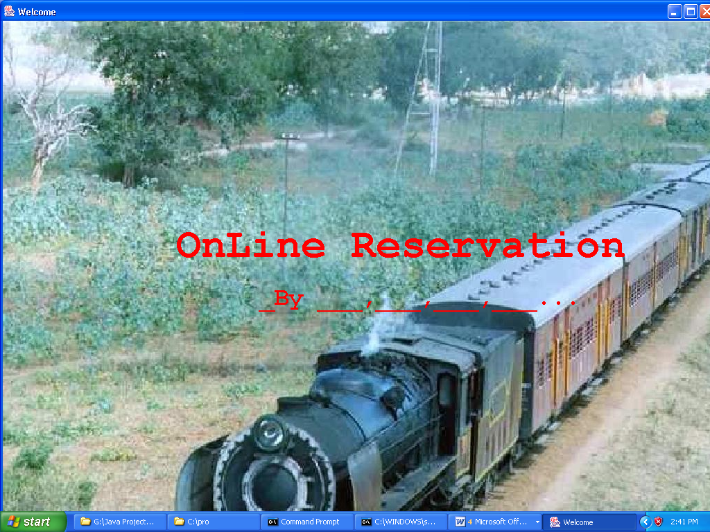

Login Screen

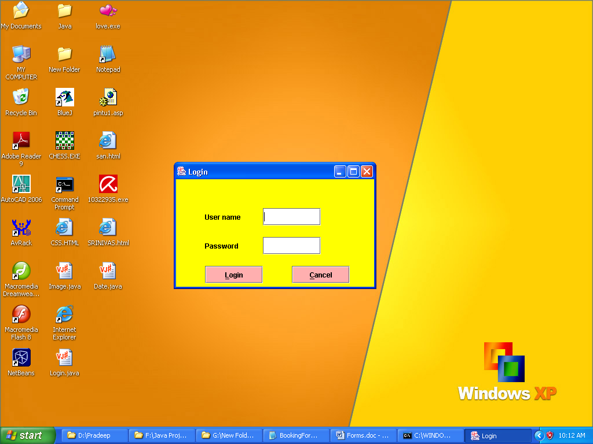

Main Screen

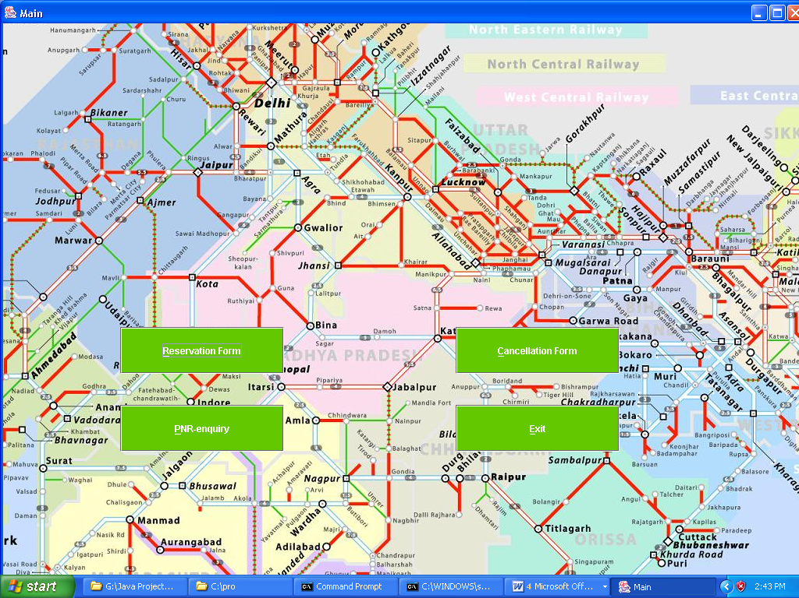

Reservation Form

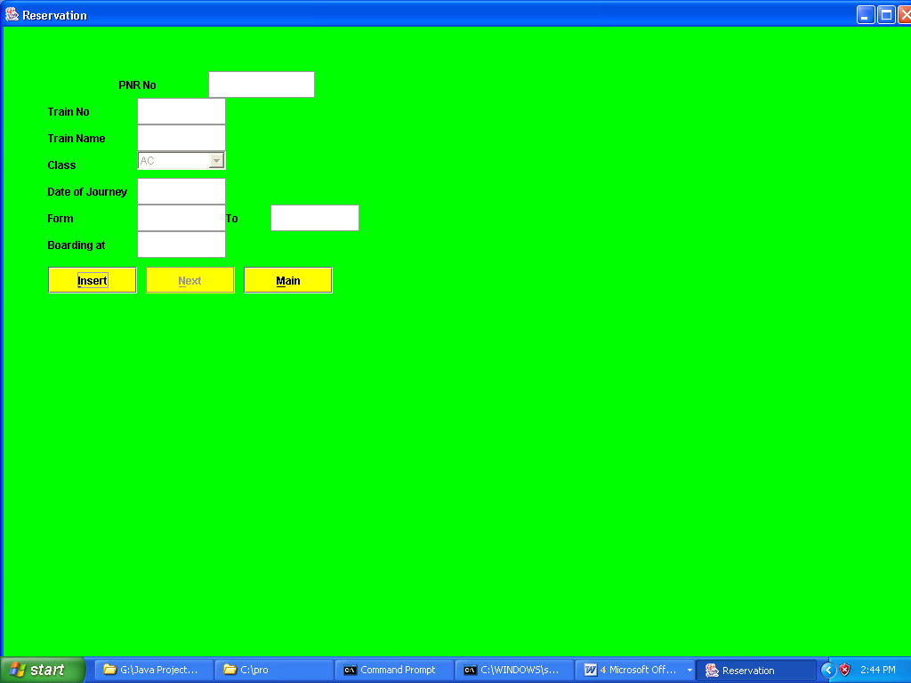

Passenger Form

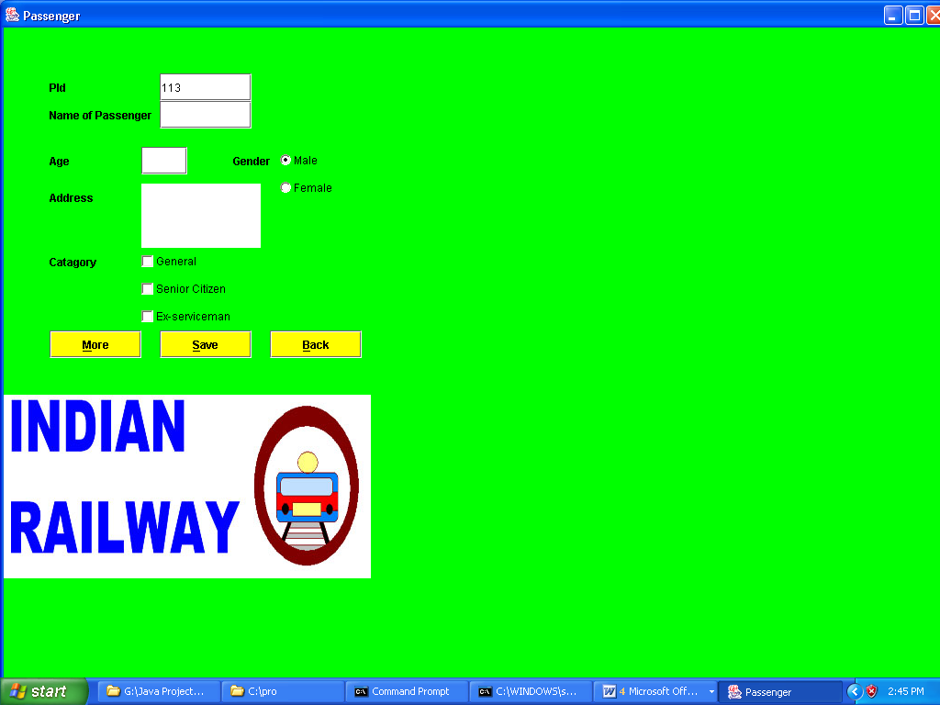

Enquiry Form

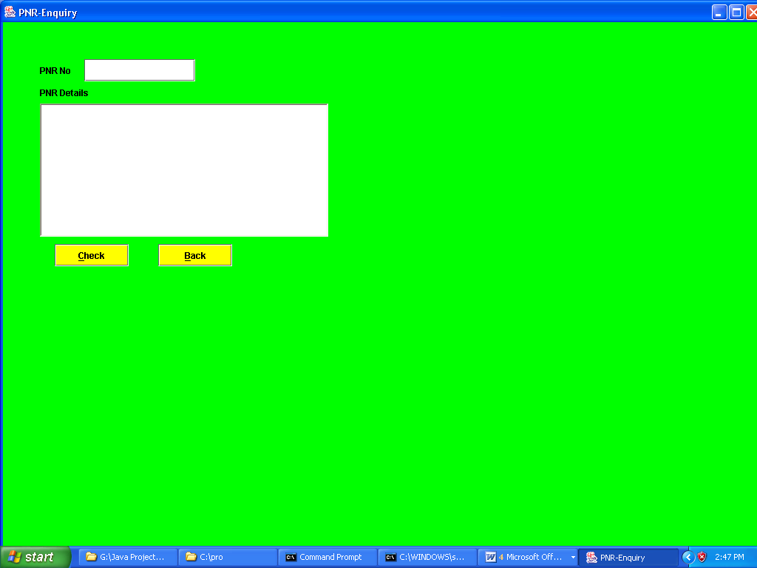

Cancellation Form

